# PIZZA HUT ANALYSIS

# Basic Analysis:

1. Total Orders Count Find the total number of orders placed.

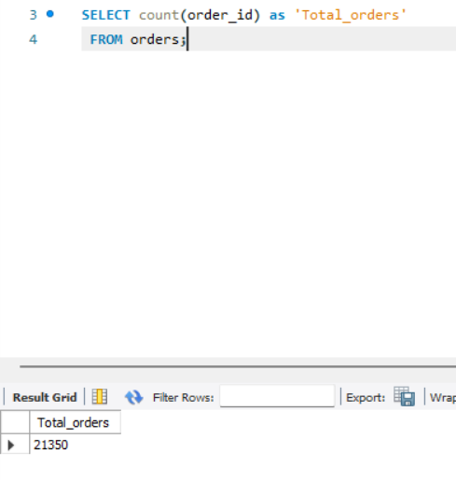

1. Revenue Calculation Calculate the total revenue from pizza sales.

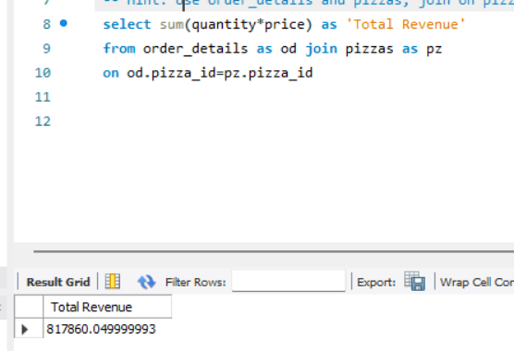

1. Most Expensive Pizza Identify the highest-priced pizza

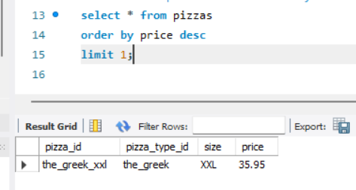

1. Most Ordered Pizza Size Determine the most frequently ordered pizza size.

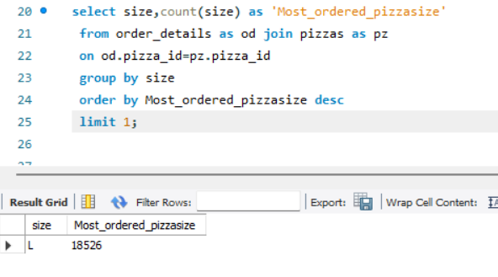

1. Top 5 Popular Pizzas List the top 5 pizzas by order quantity.

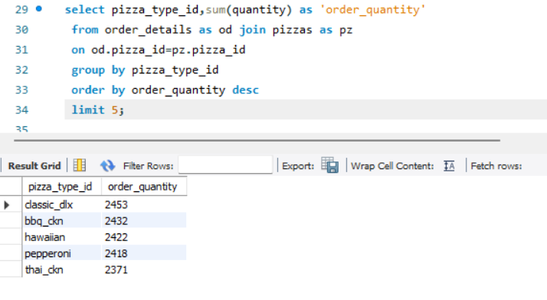

# Intermediate Analysis

1. Calculate the total quantity ordered for each pizza category.

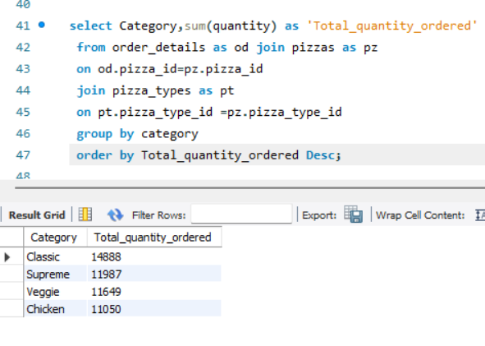

2. Order Trends by Hour Analyze the distribution of orders by hour of day.

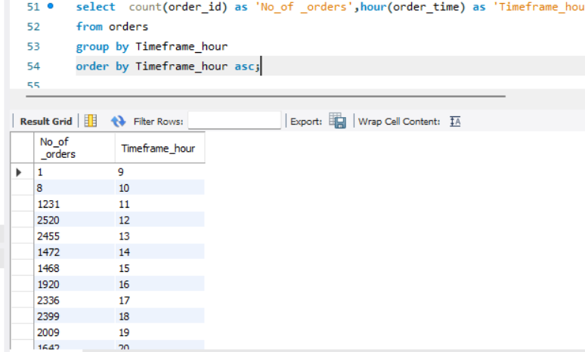

3. Pizza Distribution by Category Determine the order distribution of pizzas by category.

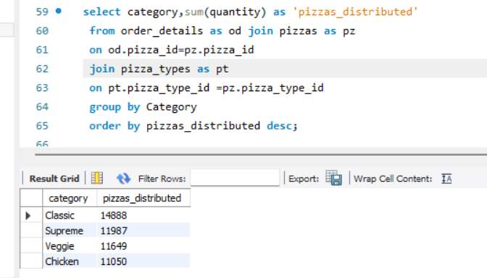

4. Average Daily Pizza Orders Calculate the average number of pizzas ordered each day.

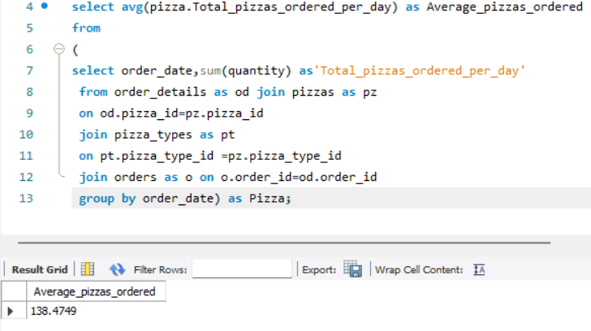

5.Top Pizza Types by Revenue Identify the top 3 pizzas based on revenue.

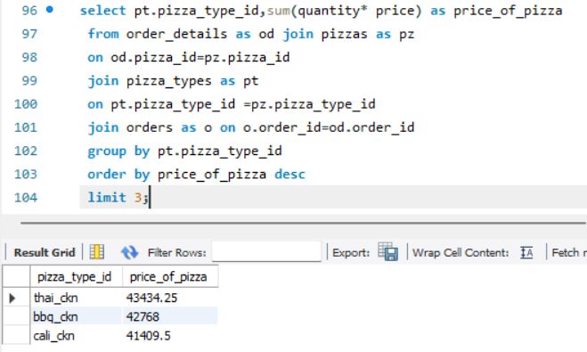

# Advanced Analysis

1)Revenue Contribution by Pizza Type Calculate each pizza type’s percentage contribution to total revenue.

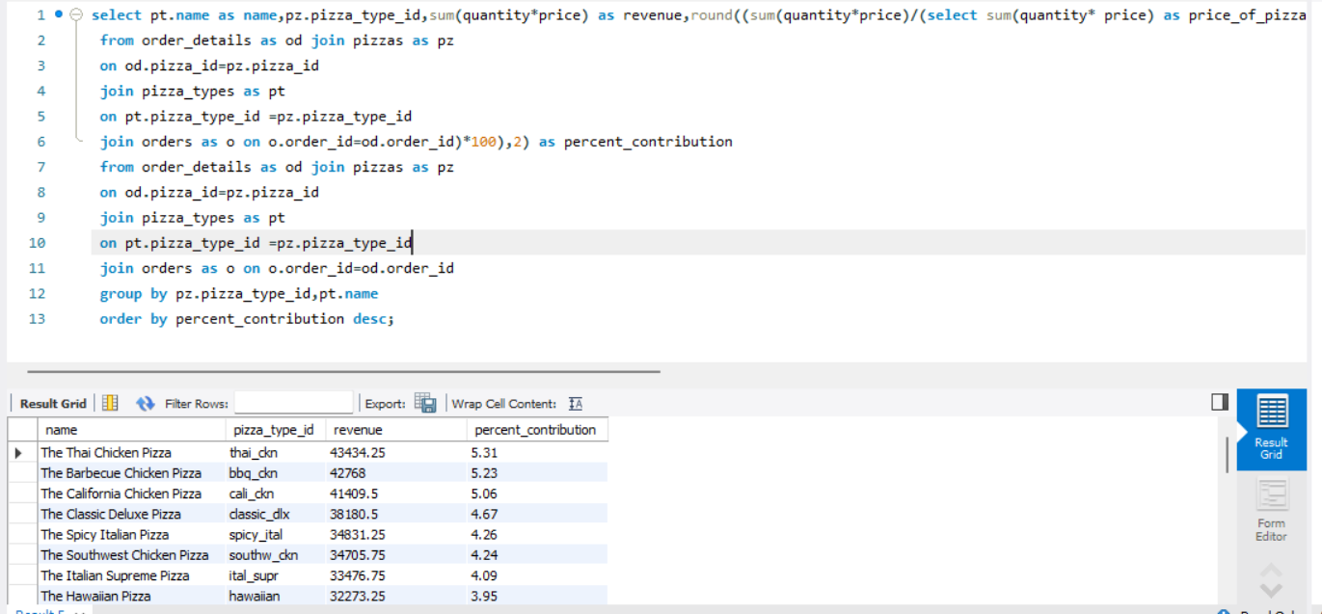

2. Cumulative Revenue Over Time Track cumulative revenue growth over time

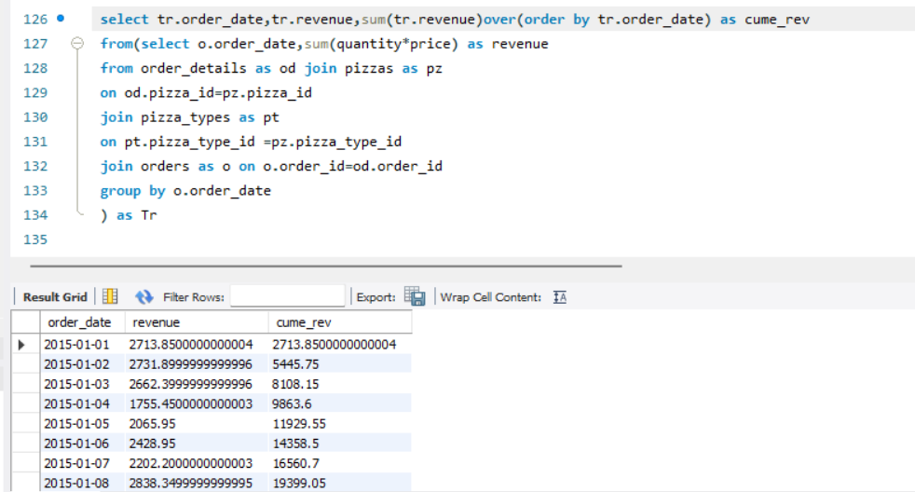

3. Top 3 Pizza Types by Revenue in Each Category Determine the top 3 pizzas by revenue within each category.

